Contents

1 Introduction 1

1.1 Team Members 1

1.2 Aims and objectives of Anti-Forensic Solutions 1

1.3 Context of the Market 2

1.4 Timescales 2

1.5 Sub-Projects 3

# 1 Introduction

**Jack Yates** - 14004093

Welcome to the final project report for Anti-Forensic Solutions (Majdi Friday AM Group A) or AFS for short. In this chapter I will discuss the following topics:

1. Team members
2. Aims and Objectives of AFS
3. Sub-projects
4. Context of the Market
5. Timescales
6. How a profit will be made.

## Team Members

We have member of the group who all contributed to the project. Upon creation of the group everyone was assigned a specific role within the team.

**Leader** - Dale Stubbs

**Deputy Leader** – Jack Yates

**Finance Director** – Ryan Malaney

**Marketing** – Asahd Mahmood

**Sub-Project 1** – Joseph Telford

**Sub-Project 2** – Andrew Slater

**Sub-Project 3** – Hamza Pervaiz

**Sub-Project 4** – Krystian Trzcionkowski

**Sub-Project 5** – Adam Morrison

**Sub-Project 6** – Collins Nyange

## Aims and objectives of Anti-Forensic Solutions

Since all the members of our group are currently taking the Computer Forensics and Analysis course, it was decided that the main aim for this project was the develop a product that would directly relate to the forensics unit. Despite this narrowing down our options to some degree, we still had a huge variety of potential ideas that we could use for our project. During the initial start up period of the project we first thought of creating an online learning tool, app and interactive program which would teach customers how to use various programs that are used for analysing computers. However after discussing this idea we found that, since we were just beginning our Computer Forensics and Analysis unit, we did not have enough knowledge in that field to create a learning tool that we would all feel proud of. As a result, we came together and collectively decided to change the idea to a something that we would be capable of doing to the standard expected of us.

Our final objective ended up being:

* To create a ‘High Street’ style online Computer Forensics shop that would allow customers to reduce the time and cost that are usually present when sending their computer off for repair.

## Context of the Market

Once we had decided what our companies product would be we began researching the market surround similar items that are already available. We found that despite numerous open source and purchasable pieces of software available on the website, there was very few software packages like ours that could be purchased both in stores such as PC World or online. As a direct result it was discovered that there would be little competition from other competitors, this would mean that we could raise our product’s prices slightly. In addition to this we also completed some trend analysis, this showed us that the modern society is becoming more and more dependent on technology such as computers and, in some cases, sending off their PC isn’t a viable option. Because of these reasons, we decided to main our products at 2 main markets, people with little computing knowledge who require services such as password recovery but don’t have the knowledge to do so. Our second target audience was customers who have some knowledge of computing and want numerous tools that they can use to both further this knowledge and, if they desired, make adjustments to the tools. Our product can service both these target audiences whilst still offering a high level of service.

## Timescales

We had from November to March to develop this project so we set numerous deadlines rather early on to ensure that work would be completed on time. However we did not take into consideration the fact that group members may have been absent or un-cooperative. We decided to set rather strict deadlines when organising the tasks as we didn’t want to fall behind and leave the project unfinished or finished with a much lower quality then we were capable of. Myself and Dale created a Gantt Chart Figure 1 that would help show us what needed to be done for what date, how much workload group members would be under and what tasks would need to be completed before others could be started.

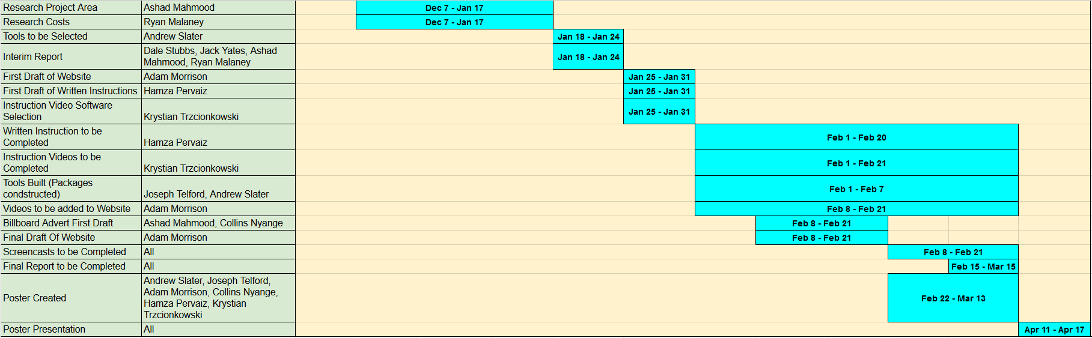

Figure 1-Gantt Chart

This helped everyone visualise where the project should be and where we should be up to. We began working on the Gantt chart on the 10th January because it was at that point that we decided to switch from the online learning program the Anti-Forensic Solutions.

We held meetings every few weeks to discuss the progress that was being made on the project and to solve any problems that required the entire involvement of the group. There were times were we would either not meet up or people would be absent from the group meetings due to a number of reasons, the forums were used during these times to ensure that everyone was informed on the current affairs.

## Sub-Projects

After research had been completed and we had scrapped the idea of an online learning platform. We decided on six sub-projects. These projects would cover every aspect of our business from the creation of the packages, to the building of our marketing campaign. Once we had decided on the sub-projects, the group members who had been assigned to sub-projects were asked which task they would prefer. In places that their was 2 or more people wanting to do a specific task a vote was cast after hearing why each person would be best suited for a specific task. Eventually we decided on the assigned sub-projects below:

* Website Creation – Adam Morrison
* How to guides for each product – Hamza Pervaiz
* How to video guides – Krystian Trzcionkowski
* Creation of packages 1,2,3 – Andrew Slater
* Creation of packages 4,5,6 – Joesph Telford
* Creation of Advertisements and social media pages – Collins Nyange

## How a profit would be made

We established that our product would start generating revenue upon launch, however the amount generated would not cover the start-up costs and would rely heavily on our advertising campaigns and online presence. We envisioned selling around 1000 USB drives with our packages on within the first year with the vision of increasing this number to around 15,000 in the second year. As we would be purchasing the USB drives in bulk, we would pay a smaller price than the usual consumer. In addition to this the cost of purchasing envelopes and delivering the drives to customers would be rather small. This low production and delivery cost would ensure that we could make a profit on each individual pen drive sold. This profit would grow as the years progressed and more customers purchased our product.

## In the next chapter

In the next chapter, our marketing director Asahd Mahmood will go into more depth about how we are going to market our product. He will provide information on our advertising strategies, the current market situation and where our company resides within this. Also, he will discuss details regarding the launch day and our plans for it.